2APHY: Nuclear Physics End of Unit Test 2009 ANSWERS

Name: _____________________________________________________ (34 + 1 marks)
OVERALL – units and significant figures: 1 mark

- In terms of their properties, explain why alpha radiation cannot penetrate paper but beta radiation can.
Alpha is a large, heavy particle that is slow moving has difficulty moving through densely packed paper molecules. 1 mark

Beta is very small, light and moves fast. Able to move through paper molecules so penetrates further. 1 mark

- Define the term “binding energy” in a nuclear physics context. (2 mark)
Binding energy is the energy needed to hold components of an atom together. 1 mark

It is released as atoms undergo fission or fusion. 1 mark

- In the chain of decays that lead from 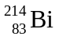 to a stable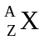, one α particle, one β particle and 2γ rays are emitted. What are the values of Z and A for nucleus X? (2 marks)

Z: _________82_________________ A: __________210_________ 1 mark each - 2 marks
- A factory has a number of underground water pipes. Pressure from one outlet clearly indicates that somewhere in the system is a water leak. It would be very expensive to dig up the thick concrete factory floor to find the leak. Explain how you could use a radioactive source to find the leak in the underground system of pipes. Include in your explanation what type of radioactive emission you would use and why. (3 marks)

As we are dealing with a thick concrete floor, the only source we can use is a gamma emitter as any other radiation would be stopped by the thick concrete floor. 1 mark

The best way to use it would be to pour a liquid containing a radioactive gamma emitting source down the pipe. You could then follow the flow using a Geiger counter. 1 mark

When there is a change in the radiation count or the count seems to spread out (water has pooled) and goes no further, you have found your leak. 1 mark

- If the original activity of a sample is 42.0 kBq and it has a half-life of 4.00 days, how much will be left after 16.0 days? (2 marks)

A₀ = 42.0 kBq A = A₀ (0.5)^{n}
Half-life = 4.00 days = 42.0 (0.5)⁴ 1 mark
Time = 16 days = 42.0 x 0.0625
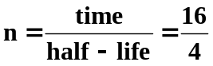 A = 2.63 kBq (3sf) 1 mark
n = 4

- The half-life of Iodine-131 is 8.00 hours. If the activity of a sample is 416 kBq, how long will it take to fall to 104 kBq? (2 marks)

A₀ = 416 kBq 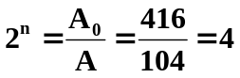
A = 104 kBq 2^{n} = 4
Half-life = 8.00 hours n = 2 1 mark

time = n x half-life
= 2 x 8.00
= 16.0 hours (3sf) 1 mark

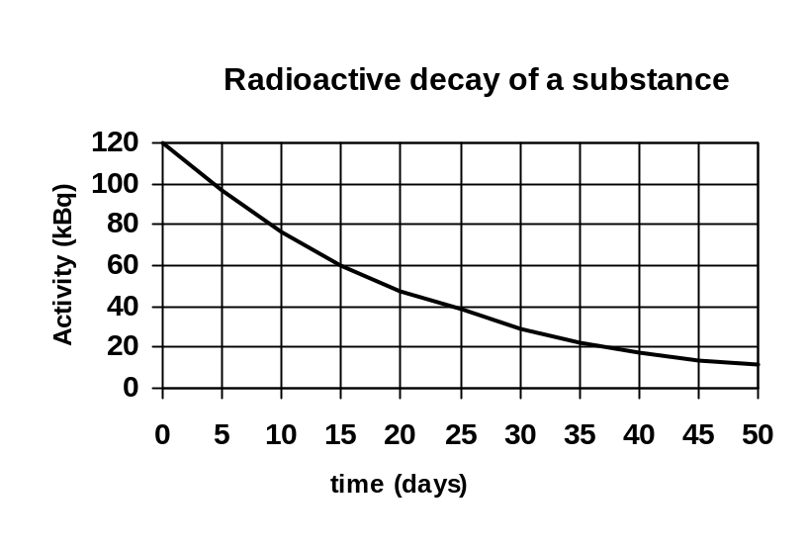7. Determine the half-life of the substance from the graph. (1 marks)

15 days 1 mark

- Food can be preserved by irradiating it with nuclear gamma radiation. Meat typically requires an equivalent dose of 1000 Sv to sterilize it. How much energy does 2.0 kg of meat absorb when it undergoes sterilization? (2 marks)

as X-rays have a quality factor of 1, absorbed dose = dose equivalent = 1000 Gy

Dose equivalent = energy
mass
Energy = mass x dose equivalent 1 mark
Energy = 2 x 1000
Energy = 2.0 x 10³ J 1 mark

9. Using an example, explain the term radioisotope. (2 marks)
A radioisotope is a radioactive isotope. 1 mark

As an isotope is a different form of the same element then carbon-14 is a radioisotope as it is a radioactive isotope of carbon-14. 1 mark

10. A radiation source and a detector can be used to measure the thickness of very thin aluminum cooking foil during manufacture. Select, from the chart below, a suitable radioisotope to be used as a radiation source.

RADIOISOTOPE | MOST USEFUL RADIATION EMITTED | HALF-LIFE
Americium-241  Cesium-137  Cobalt-60  Iodine-131  Radium-223  Strontium-90 | alpha  gamma  gamma  beta  alpha  beta | 432 years  30 years  5.27 days  8.04 days  11.4 years  29 years

Choice: __________Strontium-90 __________ 1 marks
Reason for choice: (3 marks)

As the radioisotope is to measure the thickness of Aluminium foil, the only radiation that can pass through aluminium but be affected by the thickness would be beta. 1 mark

Alpha wouldn’t pass through any thickness and gamma is unaffected by thin aluminium. 1 mark

Now beta is relatively safe to humans and shielding would be simple so the best source to use would be one that doesn’t need regular changing ie. cost must be the main factor here. The Iodine-131 with a half life of 8.04 days would always need replacing so would be an expensive choice. 1 mark

- Erica and Tameka are showing the class on the whiteboard how to calculate binding energy. The problem was to calculate the binding energy per nucleon of a Be-9 atom having a mass of 9.012182 u. Show how they correctly demonstrated this calculation with the energy in MeV. (3 marks)

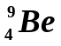 md = (mass 4 protons + mass 5 neutrons) - mass
4 protons = [(4 x 1.00728) + (5 x 1.00867)] - 9.012182
5 neutrons = 4.02912 + 5.04335 - 9.012182
nucleons = 9 = 0.060288 u 1 marks

MeV = 0.060288 x 931
= 56.128128 u per atom 1 marks

binding energy per nucleon = 56.128128 ÷ 9
= 6.24 MeV per nucleon 1 marks

Comprehension:
Read the article then answer the questions that follow.

New Scientist in April 1991.

Long Wait Ends For Medical Cyclotron

More than 20 years after it was first proposed, Australia’s first medical cyclotron was installed this month at the Royal Prince Alfred Hospital in Sydney.

The opening of the cyclotron ends many years of dispute as to where it should be sited. It took the Australian Nuclear Science and Technology Organisation (ANSTO) a long time to convince the government that the equipment should be located at a hospital and not with the research reactor at Lucas Heights in Sydney’s southern suburbs. Rex Boyd, director of the cyclotron project, says U.S. experience showed that doctors would not send seriously ill patients to a facility away from a major hospital.

By September, the National Medical Cyclotron will be cranking out radioisotopes for use in the hospital’s new positron emission tomography (PET) centre, which is expected to cater for about 1000 patients a year. PET scans help doctors to diagnose heart disease, cancer, and numerous brain disorders such as Alzheimer’s disease and epilepsy.

It will produce radioisotopes previously unavailable in Australia, the most important of which are carbon-11, nitrogen-13, oxygen-15 and fluorine-18. These isotopes are useful only for short periods of time before they break apart, which is why scientists and clinicians cannot simply import them form abroad.

(A radioisotope is a radioactive form of an element which differs in mass from the more stable form. Radioisotopes break up spontaneously emitting high energy particles. They can be used medically as tracers and for measuring concentrations of substances.)

According to Boyd, the A$22 million cyclotron - made in Belgium by Ion Beam Applications (IBA) can produce a wide variety of radioisotopes because it can accelerate either protons or deuterons. The radioisotopes are created when those particles strike a specially prepared target at high velocity. The isotopes then travel down two “beam lines” from the cyclotron to a laboratory where they are purified and turned into biologically active radio-pharmaceuticals.

It is hoped that the sale of longer-lived radioisotopes will cover the facility’s annual A$3 million operating cost. IBA is also supplying a much smaller machine to the Austin Hospital in Melbourne. The mini-accelerator, as it is called, will produce radioisotopes for PET applications alone.

Leigh Dayton, Sydney.

1. One of the radioisotopes which will be produced by the cyclotron is nitrogen -13. With reference to the article, explain what happens in the cyclotron to produce the nitrogen-13. (2 mark)

Either a proton or a deuteron is accelerated to a high velocity 1 mark

to strike a specially prepared target to produce required isotope. 1 mark

2. a. What reason is given for Australia not importing supplies of fluorine-18 and oxygen-15 for example? Explain. (2 mark)

These isotopes only have a short useful half-life before they break down. 1 mark

Time requied to import supplies would have easily have been exceeded. 1 mark

- An important medical tracer which is currently produced at Lucas Heights is technetium-99. Tc-99
has a half-life of 6.00 hours. If a 20.0 g sample of Tc-99 is produced at 6.00 am, what mass will still be active at 6.00 am the next day? (2 mark)

half-life = 6 hours m = m_{o} (0.5)^{n}
m_{o} = 20.0 g = 20.0 x (0.5)⁴ 1 mark
time = 24 hours = 20.0 x 0.0625
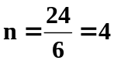 m = 1.25 g (3sf) 1 mark

3. All the major diagnostic hospitals around Australia use Tc-99. Supplies are dispatched from Lucas
Heights to all capital cities every 3 days or so. However, it is not Tc-99 which is sent but
molybdenum-99 instead. Mo-99, which has a half-life of 72 hours, produces Tc-99. The Tc-99 is then
withdrawn by the doctors as required.

a. (i) Complete the nuclear equation to show the missing particle. (1 mark)

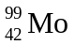 → 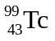 +

(ii) What type of radiation is this? Beta 1 mark

- Explain the advantage of sending Mo-99 instead of Tc-99. (2 marks)

Tc-99 has a very short half-life (6 hours) so its activity rate decreases very rapidly. 1 mark

Mo-99 has a half-life of 3 days so the hospital receives the Mo-99 which then decays to Tc-99 which they can use. 1 mark

